**LAPORAN PRAKTIKUM**

**ALGORITMA DAN PEMROGRAMAN**

**MODUL 6**



**Kelas : TINFC 2020 03 (C)**

**NIM : 20200810006**

**Nama : Egy Firmansyah**

**TEKNIK INFORMATIKA**

**FAKULTAS ILMU KOMPUTER**

**UNIVERSITAS KUNINGAN**

**2020**

1. **Pretest**

**Soal**

1. Bagaimana instruksi **WHILE** dijalankan oleh program
2. Bagaimana instruksi **DO** dijalankan oleh program
3. Bagaimana instruksi **DO-WHILE** dijalankan oleh program

**Jawab :**

* + - 1. While

Instruksi perulangan while, akan melakukan perulangan terhadap blok kode, selama kondisi bernilai true, atau benar. Berikut sintaks instruksi while:

#include <iostream>

using namespace std;

int main(){

int i=5;

while(i>0){

 cout<<" Halo World "<<endl;

 i--;

}

return 0;

}

* + - 1. Bentuk perulangan do digunakan untuk melakukan eksekusi pada suatu blok kode selama kondisi bernilai benar.

#include <iostream>

using namespace std;

int main(){

string nama;

char status;

do{

cout<<"Masukkan namamu :";

cin>>nama;

cout<<"Namamu adalah :"<<nama<<endl;

return 0;

}

* + - 1. Do-While

Berbeda dengan instruksi while, instruksi do-while akan menjalankan atau mengeksekusi blok kode minimal satu kali di awal, dan kemudian eksekusi selanjutnya bergantung kondisi dalam while. Berikut sintaks instruksi do-while:

#include <iostream>

using namespace std;

int main(){

string nama;

char status;

do{

cout<<"Masukkan namamu :";

cin>>nama;

cout<<"Namamu adalah :"<<nama<<endl;

cout<<"Lagi [Y/N]? ";

cin>> status;

}while(status=='Y'||status=='y');

cout<<"Keluar dari loop"<<endl;

return 0;

}

1. **Praktikum**
2. **Script Program**

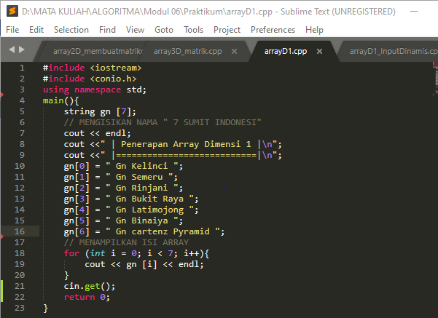

**HsHH**

**Hasil Run**

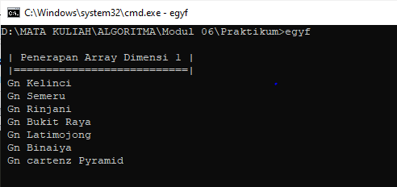

1. **Script Program**

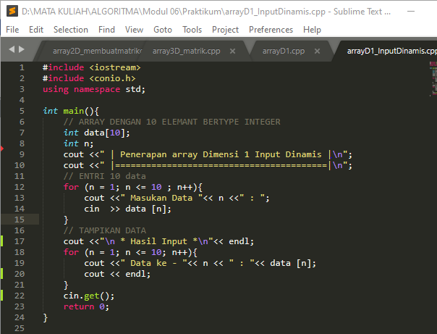

**Hasil**

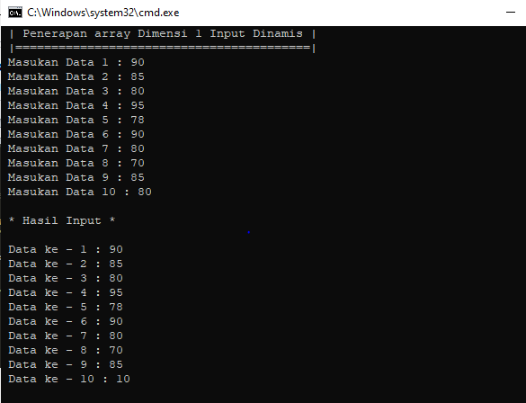

1. **Script program**

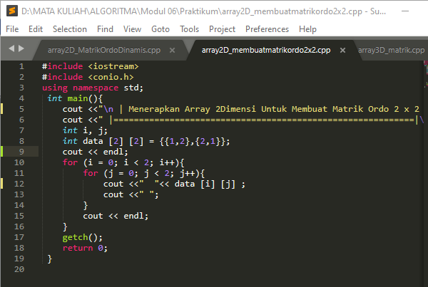

**Hasil**

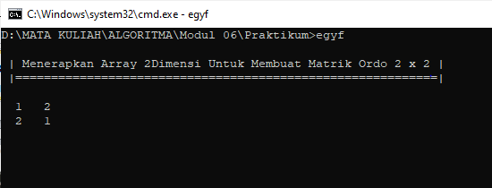

1. 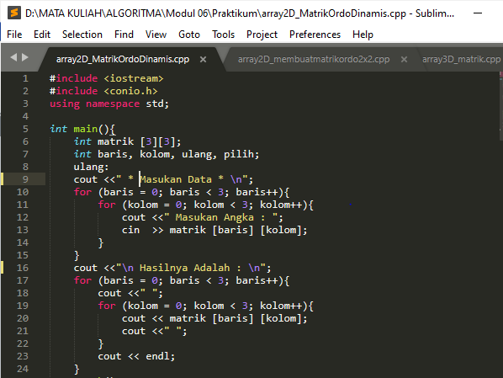**Script Program**

**Hasil**

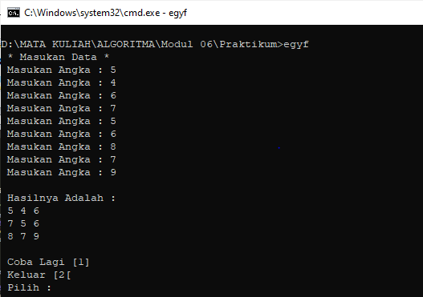

1. **Script Program**

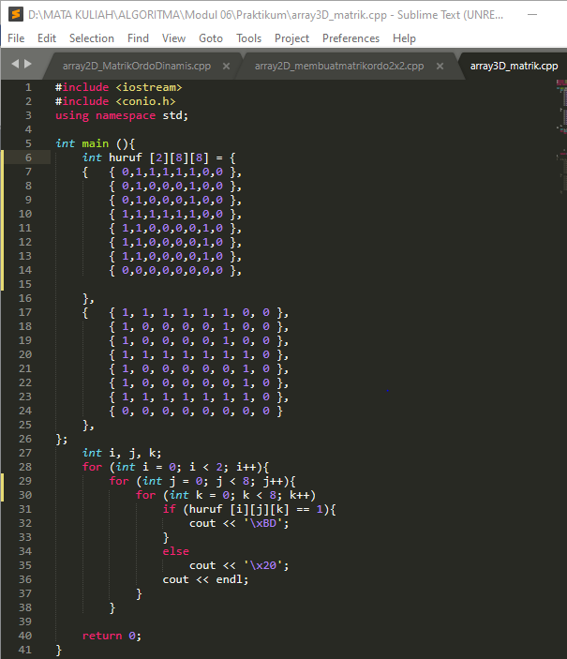

**Hasil**

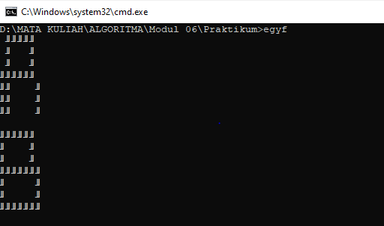

1. **Post Test**
2. Buatlah program untuk mengurutkan semua elemen array dari kecil kebesar (Ascending) contoh : 10 30 20 15 21 31 menjadi 10 15 20 21 30 31.
3. Buatlah program untuk mengurutkan semua elemen array dari besar kekecil (Descending) contoh : 10 30 20 15 21 31 menjadi 31 30 21 20 15 10.
4. Buatlah program perkalian matrik 2x3 dikalikan 3x3
5. Buatlah program array dalam menambahkan elemen dan menhitung jumlah serta rata-rata nilai elemen array

**Jawab :**

1. #include <iostream>

using namespace std;

#define MAX 100

int main(){

int arr[MAX];

int n, temp;

cout <<"\n | Mengurutkan Nilai Elemen Array (Ascending) |\n";

cout <<" |============================================|\n";

cout <<"\n Masukan Jumlah Array: ";

cin >> n;

cout <<" ---------------------\n";

if (n < 0 || n > MAX){

cout<<" Input <= 100 "<< endl;

return -1;

}

for (int i = 1; i <= n; i++){

cout <<" Nilai Eleman Ke ["<< i <<"] : ";

cin >> arr[i];

}

cout <<"\n Nilai Elemen : "<< endl;

cout <<"|==================================================|\n";

for (int i = 1; i <= n; i++){

cout <<" "<< arr[i] <<"\t";

}

cout << endl;

cout <<"|==================================================|\n";

for (int i = 1; i <= n; i++){

for (int j = i+1; j < n; j++){

if (arr[i] > arr[j]) {

temp = arr[i];

arr[i] = arr[j];

arr[j] = temp;

}

}

}

cout <<"\n Hasil Pengurutan Ascending : "<< endl;

cout <<"|==================================================|\n";

for(int i = 1; i <= n; i++){

cout <<" ";

cout << arr[i]<<"\t";

}

cout << endl;

cout <<"|==================================================|\n";

cin.get();

return 0;

}

**Hasil Run :**

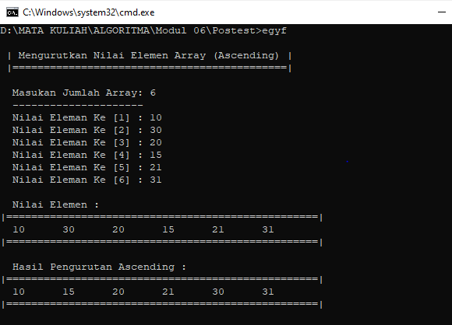

1. #include <iostream>

using namespace std;

#define MAX 100

int main(){

int arr[MAX];

int n, temp;

cout <<"\n | Mengurutkan Nilai Elemen Array (Descending) |\n";

cout <<" |============================================|\n";

cout <<"\n Masukan Jumlah Array : ";

cin >> n;

if (n < 0 || n > MAX){

cout<<" Input <= 100 "<< endl;

return -1;

}

for (int i = 1; i <= n; i++){

cout <<" Nilai Eleman Ke ["<< i <<"] = ";

cin >> arr[i];

}

cout <<"\n Nilai Elemen : "<< endl;

cout <<"|==================================================|\n";

for (int i = 1; i <= n; i++){

cout <<" "<< arr[i] <<"\t";

}

cout << endl;

cout <<"|==================================================|\n";

for (int i = 1; i <= n; i++){

for (int j = i+1; j < n; j++){

if (arr[i] < arr[j]) {

temp = arr[i];

arr[i] = arr[j];

arr[j] = temp;

}

}

}

cout <<"\n Hasil Pengurutan Descending : "<< endl;

cout <<"|==================================================|\n";

for(int i = 1; i <= n; i++){

cout <<" ";

cout << arr[i]<<"\t";

}

cout << endl;

cout <<"|==================================================|\n";

cin.get();

return 0;

}

**Hasil Run**

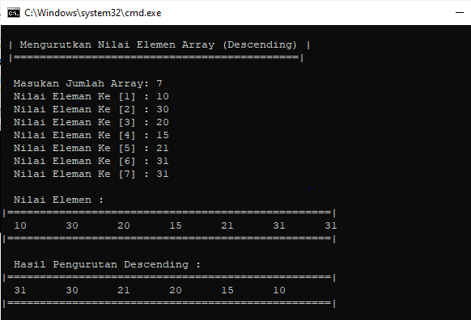

1. #include <iostream>

#include <conio.h>

#include <iomanip>

using namespace std;

main(){

int A[2][3],B[3][3],C[3][3],i,j,k;

cout <<"\n | PERKALIAN MATRIK (2 x 3) * (3 x 3) |\n";

cout <<" |====================================|\n";

cout<<" | inputkan matrik A : \n";

cout<<" |-------------------- \n";

for (i = 0; i < 2; i++){

for (j = 0; j < 3; j++){

cout <<" Elemen ke "<< (i+1) <<","<< (j+1) <<" : ";

cin >> A[i][j];

}

}

cout <<"\n | Matrik A (2 x 3) |\n";

cout <<" |------------------|\n";

for (i = 0; i < 2; i++){

for (j = 0; j < 3 ;j++){

cout << setw(4) << A[i][j];

}

cout << endl;

}

cout << endl;

cout <<" |====================================|\n";

cout <<" | Inputkan matrik B : \n";

cout <<" |-------------------- \n";

for (i = 0; i < 3; i++){

for (j = 0; j < 3; j++){

cout <<" Elemen ke "<< (i+1) <<","<< (j+1) <<" : ";

cin >> B[i][j];

}

}

cout <<"\n | Matrik B (3 x 3) |\n";

cout <<" |------------------|\n";

for (i = 0; i < 3; i++){

for (j = 0; j < 3; j++){

cout << setw(4) << B[i][j];

}

cout << endl;

}

for (i = 0; i < 3; i++){

for (j = 0; j < 3; j++){

C[i][j] = 0;

for (k = 0; k < 3; k++){

C[i][j] += A[i][k] * B[k][j];

}

}

}

cout <<"\n |================================|\n";

cout <<" | Hasil Perkalian Matrik A x B : |\n";

cout <<" |================================|\n";

cout <<" |===============|\n";

for (i = 0; i < 3; i++){

for (j = 0; j < 3; j++){

cout << setw(5) << C[i][j];

}

cout << endl << endl;

}

cout <<" |===============|\n";

getch();

return 0;

}

**Hasil Run**

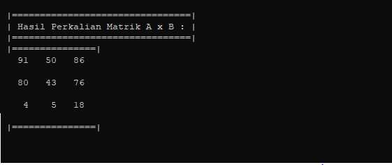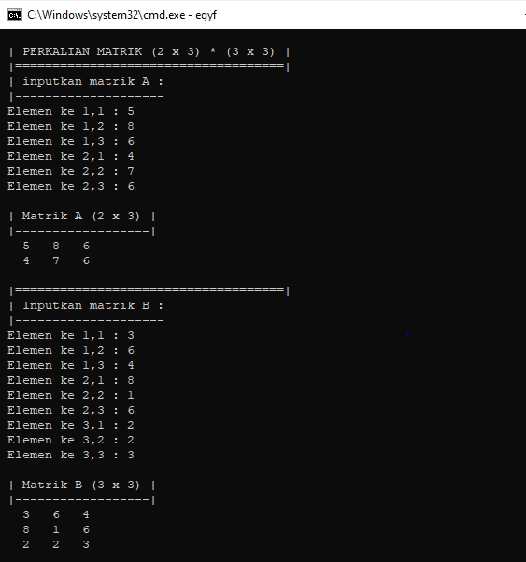

1. #include <iostream>

#include <conio.h>

using namespace std;

int main(){

int array[100], n;

float rata, total;

cout <<"\n | Menghitung Rata Rata Nilai Elemen Array |\n";

cout <<" |=========================================|\n";

cout <<"\n Masukan Banyak Nilai : ";

cin >> n;

for (int i = 1; i <= n; i++){

cout <<" Nilai Ke ["<< i <<"] = ";

cin >> array[i];

total = total + array[i];

}

cout << endl;

rata = total / n;

cout <<" Hasil Total Nilai = "<< total << endl;

cout <<" Hasil Rata-Rata Nilai = "<< rata << endl;

cin.get();

return 0;

}

**Hasil Run**

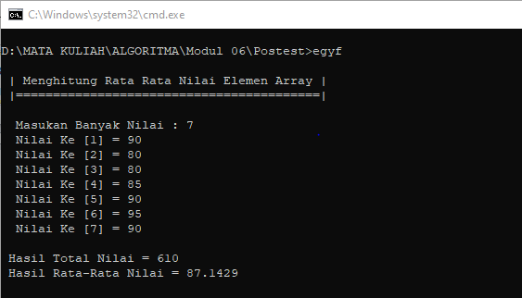

1. **Tugas Mandiri**
2. Analisa Program
3. Lakukan proses kompilasi
4. Jalankan program
5. Ubar menjadi program dinamis
6. Buat program menghitung nilai rata rata dan tentukan modus nilainya.
7. Buatlah program menggunakan array 3 dimensi dalam membuat tampilan3 dimensi berbentuk benda

**Jawab :**

1. #include <iostream>

#include <conio.h>

#include <iomanip>

using namespace std;

main(){

int A[4][4],i,j,k;

cout <<"\n | PERKALIAN MATRIK (4 x 4) |\n";

cout <<" |==========================|\n";

cout<<" | inputkan matrik : \n";

cout<<" |------------------- \n";

for (i = 0; i < 4; i++){

for (j = 0; j < 4; j++){

cout <<" Elemen ke "<< (i+1) <<","<< (j+1) <<" : ";

cin >> A[i][j];

}

}

cout <<"\n | Matrik (4 x 4) |\n";

cout <<" |----------------|\n";

for (i = 0; i < 4; i++){

for (j = 0; j < 4 ;j++){

cout << setw(4) << A[i][j];

}

cout << endl;

}

cout <<" |----------------| \n";

getch();

return 0;

}

**Hasil Run**

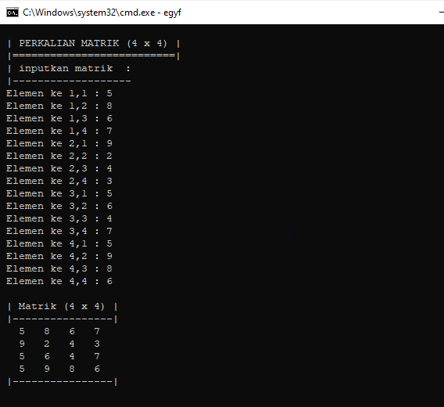

1. #include <iostream>

using namespace std;

int main(){

int e[100], g[100], y, f, modus, total=0, jumlah;

int rata;

cout <<"\n Jumlah Nilai Yang Dimasukan : ";

cin >> jumlah;

cout <<" -----------------------------\n";

for (y = 0; y < jumlah; y++){

cout <<" Masukan Nilai Ke - ["<< (y+1) <<"] : " ;

cin >> e[y];

total +=e[y];

}

// Menentukan Modus

for (y = 0; y < jumlah; y++){

modus = 0;

for (f = 0; f < jumlah; f++)

if (e[f] == e[y]){

modus ++;

g[y] = modus;

}

}

cout <<"\n Frekuansi Nilai Yang Dimasukan Adalah : \n";

for (y = 0; y < jumlah; y++){

if (y > 0){

for (f = 0; f < y; f++)

if (e[y] == e[f] && g[y] == g[f])

cout <<" Nilai "<< e[y] <<" = "<< g[y] <<" Siswa "<< endl;

}

rata = total / jumlah;

cout <<"\n Nilai rata rata = "<< rata << endl;

cin.get();

return 0;

}

**Hasil Run**

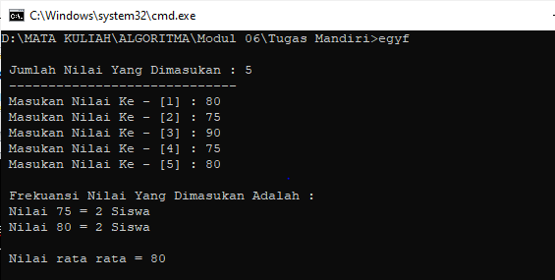

1. #include <iostream>

#include <conio.h>

using namespace std;

main (){

int huruf [1][15][15] = {

{ { 0, 0, 0, 1, 1, 1, 1, 1, 1, 1, 1 },

{ 0, 0, 1, 0, 0, 0, 0, 0, 0, 1, 1 },

{ 0, 1, 1, 1, 1, 1, 1, 1, 1, 0, 1 },

{ 0, 1, 0, 0, 0, 0, 0, 0, 1, 0, 1 },

{ 0, 1, 0, 0, 0, 0, 0, 0, 1, 1, 0 },

{ 0, 1, 1, 1, 1, 1, 1, 1, 1, 0, 0 }

},

};

cout << endl;

cout <<" * Membuat Benda 3 Dimensi Dengan Array 3 Dimensi *\n";

cout <<" |----------------------------------------------| \n\n";

int i, j, k;

for (int i = 0; i < 1; i++){

for (int j = 0; j < 7; j++){

for (int k = 0; k < 15; k++)

if (huruf [i][j][k] == 1){

cout << '\xBD';

}

else

cout << '\x20';

cout << endl;

}

}

return 0;

}

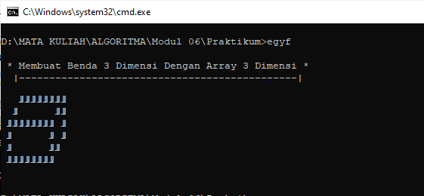**Hasil Run**

Program Menggunakan Aplikasi Pemrograman SUBLEME TEXT3